FLUCK OPS - CASA GRANDE
SITUATION-
General Overview: The City of Casa Grande (not just the police department independently) entered into the main Flock Safety contract. Key details on the primary (current) contract:
● On September 15, 2025, the Casa Grande City Council unanimously approved Resolution No. 5818.
● This resolution accepted the sole-source offer from Flock Group, Inc. for the 10-year “Safe City Initiative” (≈ $10 million) and authorized the execution of the contract.
● The contract documents list the customer as “AZ – Casa Grande PD” (Casa Grande Police
Department), but the agreement is a city contract approved and authorized by the City Council.
Who recommended and who signs:
● Police Chief Mark McCrory recommended the contract to the Council (staff report prepared by Deputy Chief Brian Ramirez).
● After Council approval, the individual authorized to execute/sign the contract on behalf of the City is the City Manager, Larry Rains (standard practice for Casa Grande municipal contracts).
● The City Clerk (Adriana Carpio-Solis) attests, and the City Attorney (Brett Wallace) approves the contract as to form.
This follows the same pattern as the original smaller 2022 Flock ALPR contract (Resolution 5463), which was also Council-approved and executed by city officials.

Opponent: Flock and other ALPR use in Casa Grande Incorporated contracted by
various persons in govt entities. Cameras; **According to DeFlock (crowdsourced mapping via OpenStreetMap contributors and related projects, as aggregated on Deflock The USA and DeFlock Arizona sites), Arizona has at least ~2,338–2,459 reported automated license plate readers (ALPRs), the large majority of which are Flock Safety cameras.** These figures represent *volunteer-reported and mapped* cameras (not an official complete inventory). Coverage is incomplete —cameras may exist that have not yet been reported—and numbers update as new reports come in. Some non- Flock ALPRs (e.g., Motorola/Vigilant or others) are included in the totals. Data sources include OpenStreetMap/FlockHopper, Eyes On Flock portals, and community contributions. Figures below are primarily from the Deflock The USA Arizona report (as of the latest available crawl around mid-2026).
1. Size- *Casa Grande**: 110 cameras, ~90 (authorized ~90; actual often in the mid-to-
high 80s).
2. Activity- surveillance and protection of the streets of those contracting, approving or otherwise using and affiliated with the unconstitutional 4th Amendment violating mass-spy system. We MUST keep those "streets" safe for they and their "neighbors" as they do ours.
3. Location- various, City of Casa Grande Inc, Arizona.
4. Unit-

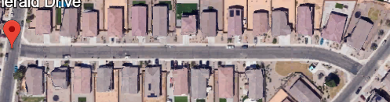
1. PRIMARY LOI (Location of Interest) #1; Larry Dale Rains' street, City Manager
1. E. Emerald Dr Casa Grande, AZ 85122
2. Office - 520.421.8600
3. Office- larryr@casagrandeaz.gov
4. Fig-1 EMERALD DR-

2. PRIMARY LOI #2, Day-1; Brett Wallace' street, City Attorney of Casa Grande, Arizona.
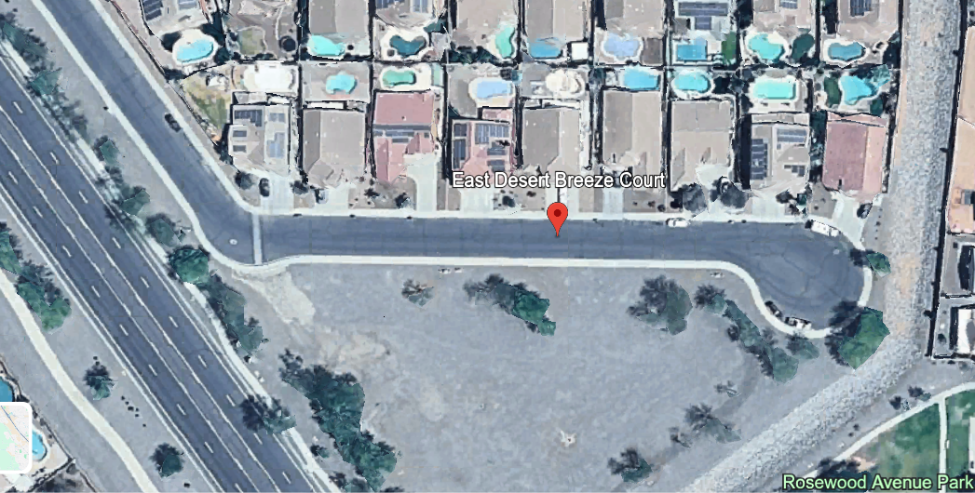
1. E Desert Breeze Ct Casa Grande, AZ
85122
2. Office - 520.510.9574
3. bwallace@casagrandeaz.gov
4. Fig-2 DESERT BREEZE CT

3. PRIMARY LOI #3, Day-2; **Casa Grande Police
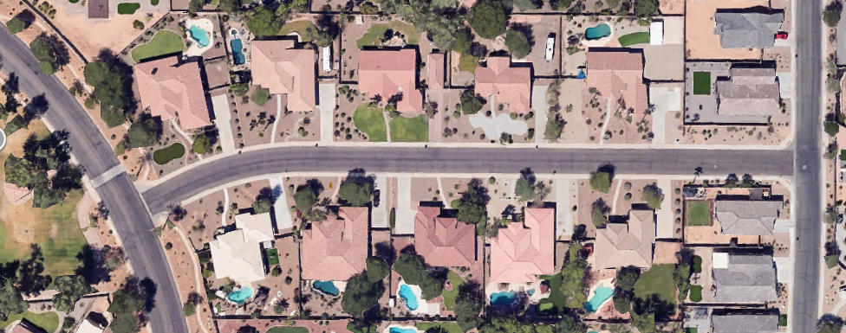
Chief Mark McCrory's street**:
1. E Wiley Way Casa Grande, AZ 85122
2. Office - 521.420.8600 ext7
3. chiefofpolice@casagrandeaz.gov
4. Fig-3

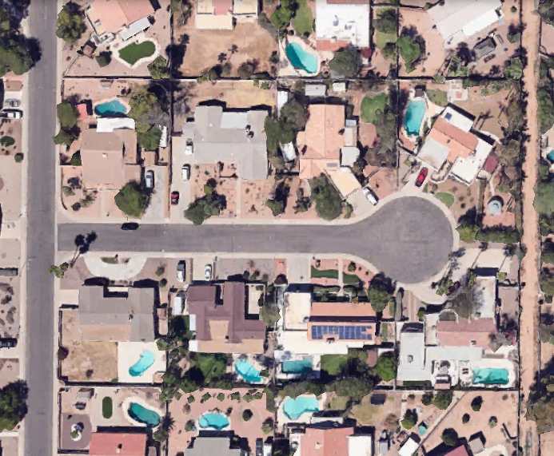
4. SECONDARY LOI #4, Day-3; Casa Grande
Mayor Lisa Fitzgibbons' street:
1. E Laurel Cir Casa Grande, AZ 85122
2. 520-421-8600
3. lfitzgibbons@casagrandeaz.gov
4. Fig-4

5. SECONDARY LOI #5, Day-4; Casa Grande City
Judge's street:
1. **NO RESULTS FOUND?**
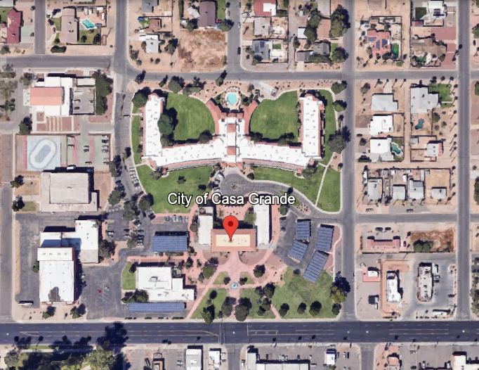
She scrubbed her Figure
3: public information.

6. City Hall, Day-5
1. 510 E Florence Blvd, Casa Grande, AZ 85122
2. Fig-5

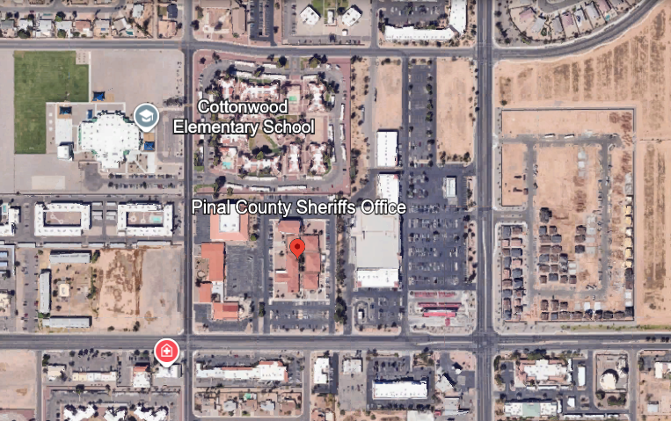
7. Sheriffs Dept, Day-6
1. Pinal County Sheriffs Office, 820 E Cottonwood Ln, Casa Grande, AZ 85122
2. Fig-6

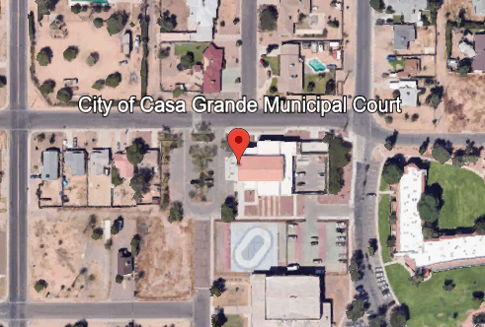
8. City Courthouse, Day-7
1. 375 E 9th Street, Casa Grande, AZ 85122
2. Fig-7

9. City Mgrs Office, Day-8
1. 510 E Florence Boulevard, Casa Grande, AZ 85122
2. Fig-8

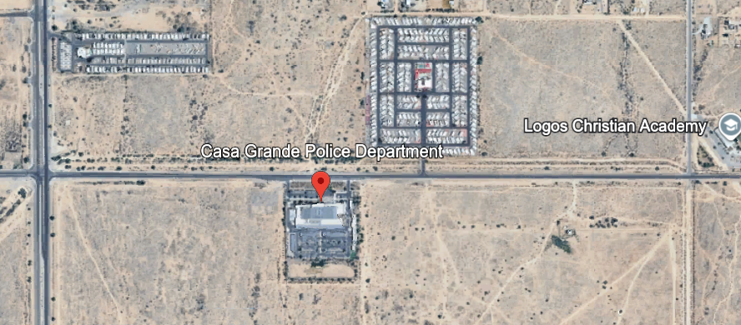
10. Police Dept, Day-9
1. 373 E Val Vista, Casa Grande, AZ 85122, United States
2. Fig-9

5. Time- current and continuing.
6. Equipment- Flock cameras et al, police vehicles and standard personal load-outs.
1. Humint known- what enemy human intel assets are known?
1. None.
2. Elint known- what known electronic intel surveillance, crowd deterrent,
electronic attack capabilities are known? Audio on the cameras?
1. None.
3. Sigint known- what enemy signals (electronic comms) gathering and/or
interruption capabilities are known? ELSAG's?
1. None.
4. Collaborators known- who is working with the specific enemy but not
necessarily an enemy group member? Police Officers, City
representatives and employees that did not approve or sign the contract.
5. Collaborators suspected- UNK.

7. DRAWD-
1. Defend- Can and how can the enemy defend their position? Call out the
popo and have us harassed and/or falsely arrested.
2. Reinforce- Can and how can the enemy reinforce their position and
where are the reinforcements going to come from and what avenues of
approach will they use?
1. County Sheriffs, AZ Highway Patrol, AZ Dept of Public Safety
personnel can be called to bear.
2. Approach from the west on Hwy 8, the east on Hwy 10, the North on
Hwy 10, and avrious secondary roads CG to surrounding towns.
3. Air assets.
3. Attack- Can the enemy attack, how, with what?
1. Ground and air vehicles, firearms, crowd control tools.
4. Withdraw-
1. They won't unless they see that there is no law they can use against us.
5. Delay- Can the enemy delay us, how, with what/who?
1. Detainment.
2. False arrest.

FRIENDLY:
1. SITUATION-(Overall Summary here)
Attached coalition units- Groups/units/individuals working directly with you.
Upper Echelon- Pinal County Sheriff has ended the County Flock contract.
My Echelon- Surveilled and pissed off.
2. MET-TC
Lower Echelon- Exterior units working for us as subordinate teams with missions and objectives that are needed to affect our higher level objectives... A security perimeter watch team is needed to warn me of incoming LEO.

MISSION
1. Mission, ours, general summary. Apply legal political peer pressure on public officials without stalking or harassing them urging them to cancel all ALPR and AILPR contracts and systems use in Casa Grande, and OBEY the will of The People and the US Constitution and it's Fourth Amendment limitations and protections. If they can watch us from public property, so to We can watch them, 24/7/365. Reference et al;
### Key Cases
- **Glik v. Cunniffe**, 655 F.3d 78 (1st Cir. 2011) — Landmark decision. A citizen openly filmed police making an arrest on Boston Common. The court held that filming government officials performing duties in a public space is a “basic, vital, and well-established” First Amendment right. The arrest under a wiretap statute violated both First and Fourth Amendment rights.
- **Gericke v. Begin**, 753 F.3d 1 (1st Cir. 2014) — Extended *Glik*. Affirmed the right to film a traffic stop from a public place.
- **Fields v. City of Philadelphia**, 862 F.3d 353 (3rd Cir. 2017) — Held that the First Amendment protects photographing or filming police conducting official duties in public, even without an intent to criticize, protest, or challenge the officers. Recording itself is protected.
- **Turner v. Driver**, 848 F.3d 678 (5th Cir. 2017) — Recognized a First Amendment right to film a police station from a public sidewalk (subject to reasonable time, place, and manner restrictions). Officers received qualified immunity because the right was not yet clearly established in that circuit at the time of the incident.
- **Smith v. City of Cumming**, 212 F.3d 1332 (11th Cir. 2000) — Early recognition of a First Amendment right, subject to reasonable time/place/manner limits, to photograph or videotape police conduct on public property as a form of gathering information about public officials.
- **Fordyce v. City of Seattle**, 55 F.3d 436 (9th Cir. 1995) — Recognized a First Amendment right to film matters of public interest, including police activity at public events.
- **Irizarry v. Yehia** (10th Cir. 2022) — Affirmed the First Amendment right to film police performing duties in public.
- **Massimino v. Benoit** (2nd Cir. 2026) — Recent decision joining the majority of circuits. Affirmed the right to film the exterior of a police station and publicly visible activity from a public sidewalk.
### Related Principles - Courts often cite broader First Amendment precedents on public forums (streets, sidewalks, parks) and the right to gather information about government (e.g., principles from cases like *Branzburg v. Hayes*). Recording is treated as protected expression or newsgathering when done from a place where the filmer is lawfully present and without interfering with official duties.
**Note**: Qualified immunity can still shield officers in individual lawsuits if the right was not “clearly established” in that jurisdiction at the time. Limits include not obstructing police and respecting privacy expectations in non-public settings. These cases are the primary references used in arguments, litigation, and know-your-rights materials on the topic.

2. Equipment necessary – “BBB”.
1. Beans – snacks, easy meals.
2. Bullets – ammo & other necessary equipment necessary for the
mission. Usual EDC, nothing special.
3. Bandaids – medical resources needed/available. IFAK as always.
3. Time - planning 2 days. Execution 5 full work days.
4. Troops available - UNK at this time. Possibly Gorbosh. Working on it...
5. Civilian considerations. No camo, grayman civvies but not hiding, no
plate carriers etc.

2. MISSION:
Enemy- Keep and grow the camera systems.
Friendly- ALPR's and AILPR's get contracts canceled, legislatively made illegal, or destroyed. This system has to go away ASAP before our enemies turn it into a surveillance system against American
patriots and troops.
STRATEGIES-
1. Example; Apply typical political peer pressure legally by instilling concern that cannot be proven onto the persons contracting these abominations. Set up as media would on a roadside within a legal area to park and either stand on roadside, sidewalk, or park and set up tripod/camera/sign/chair in bed of the truck to view the street on which these persons who contracted them and use them live, preferably with their home in view. The major viewing area must be the “public” roadway in front of their homes so as to not be accusable of ”stalking” or “harassing” them specifically. Set up a livestream on either X or Rumble, distribute the viewing link to all other SocMed and Members to distribute also. Make commentary on who may or may not live on this street?...
Begin with less aggressive targets such as City Manager home streets, then City Attorneys, City Mayors, County Commissioners, County Courthouse employee entrance, County Attorney/s home streets, County Judges home streets. The idea is to begin with the low-hanging fruit to express discontent and instill a sense of caution that may be expressed up the govt CoC to affect. Neighbors may also become discontent with their streets being watched as well as any who travel on them. Carried out solo is looking like a 25 day operation executing every day. ** G laws/Ordinances at end of doc.
Example; (surveillance). Not applicable as it would be stalking.
Example; devise a method to cause multiple, widespread 'hits' on the ALPR system to overload the users and responding LEO...
4. Signage messaging -
Watching the Watcher's Public Roadways — For Mutual Safety
Public Road. Public Eyes. Keeping Safety Reciprocal.
Flock Cameras Watch Us. We Watch Back.
Safety Works Both Ways Flock.
Citizen Oversight: Monitoring for Your Safety on Public Property
Reciprocal Surveillance — Public Roads, Public Accountability
We Watch the Watchers Till They Cancel Contracts and Dismantle Cameras.
Your Flock Cameras Are Not Invisible. Neither Are You.
Contracted with Flock? Enjoy the Attention.
Public Road. Private Contract. Public Eyes on You.
Surveillance Cuts Both Ways.
Flock Safety Partners Under Continuous Observation
You’re Watching Us. We’re Documenting You.
No One Gets to Watch Unwatched.
Get the Flock Out – Keep Our Roads Free
Unflock Your Freedom
No Flock, No Track
Deflock the Streets
Flock Off Our Privacy
Stop the Flock Watch
Plate Privacy Starts with DeFlock
Break the Flock – End Mass Tracking
Don’t Get Flocked

Flock-Free Communities
Your Drive, Not Their Database
Kick the Flock to the Curb
Surveillance Sucks – DeFlock Now
No Cameras, No Compromise (or Flock Cameras? Hell No.)
Protect the Plate, Reject the Flock
These lean into wordplay on “Flock,” emphasize privacy/freedom, and stay short and
memorable for signs, social media, petitions, stickers, and local organizing.
3. EXECUTION: this is back-planned but forward-written from the final extract back
to the beginning act of the op. Intel gathering & prep
8/XX/26 - Run 5PO by S3 and Staff for edits/approval.
8/XX/26 - prep all comms gear, foods, IFAK check, EDC function checks, EDC
cellphone charge, radio charge, ags up truck and check other fluids.
8/XX/26 - handwrite on index cards directions to Objective.
8/XX/26 - 2 days prior to execution, send messages to Notify List of DTG of livestream.
List includes JM, OD, G, JB, TM, TheRealDeflock, MaricopaLibertarians, BB, Steve Ferguson, George Nemeh needs several days notice if he wants to be onsite, ViolentVixen,
@JensTwoCentsArizona, Mohave Free Press, etc.
8/XX/26 - **without EDC phone**, goto family $, DG etc purchase prepaid smartphone
w 500 or unlimited minutes solely for operation. Download Rumble, Rumble Studio and
X to it. Make login checks for function. Turn off phone, remove battery and store for
Activity.
8/XX/26 - AWAY FROM HOME AND MY EDC CELLPHONE, Set up streaming in
Rumble, ?X?, put on schedule.
8/XX/26 - Make sterile wallet and truck contents, only DL and 1 credit card, little cash
and Med card.
8/XX/26 - Print and fold pamphlets, make signs etc.
8/XX/26 - Pack truck with gear, pamphlets, signs etc everything.
8/XX/26 - 1 day before Op, notify list of personalities of incoming livestream for
FLUCKOPS.
8/XX/26 - 0600 hrs - Departure. Travel to AO Entry.
8/XX/26 - 0645 - Arrival OP, confirm Observation Post on Public property location per current conditions.
8/XX26 - Commence opening live-stream video channels, check upload speeds, messgae safety contacts sitrep and safety, commence live stream of "roadway".
8/XX/26 - 0700 hrs - continue;
8/XX/26 - 1800 hrs - Turn off and stow Op phone in fara bag. Pack gear, police call area for trash,exfil Objective and proceed home.
8/XX/2026 - follow up with calls to all POI's (persons of interest) to inquire about ALPR
use status.

4. ADMIN & LOGISTICS:
1. Available Satellite Support- none.
2. Available Air Support- Medivac 911, Equipment/resupply drops - none, Drone
surveillance/overwatch - I have one someone can use for us, comms relay -
needed?, personnel extract - probably a good idea to have a QRF extract
team...

3. Available External Ground- Medivac, Equipment/resupply drops. Drone
surveillance/overwatch, comms relay, personnel extract.
4. Vehicles- My POV, team member POV's.
5. Mission gear & Equipment list-
M4 rifle-1 X#Mags-4 Backpack- Cammies- Helmet- Radio- M9 pistol-1 X#Mags-4 Chestrig/body armor- IFAK- Camelbak- X#Bearspray-1 X#Zipcuffs- X#radio/headset- Xgoggles- #gasmask/filtermask- #gloves- #etc- #etc- -------

5. Command & Control:
COC- (Unit/Cdr/callsign etc) This is the entity that the Team is calling back to
during the Operation.
1. T?
Friendly controllers/assets attached- these are personnel from other units,
agencies, or groups attached that are not regular members of the team.
1. N/A.
Comms gear- complete list of all comms gear needed.
Cell[phones
GMRS
Comm Freqs-
Primary-
Alt-
Rally Points-
Primary-
Alt-
Insertion Point – this is generally somewhere on the FEBA (Forward Edge of the Battle
Area), or a coordinate for air or sea insertion, or can be a street address for Urban operations.
Medivac Contact & Protocol- call 911.
Nearest FRIENDLY MedFac- NextCare Urgent Care
Located at 1683 E Florence Blvd #7, this facility offers walk-in medical care
with extended hours: 8:00 AM – 8:00 PM on weekdays and 8:00 AM –
4:00 PM on weekends.

Team Leader writes list of all personnel attending the Operation and provides to HQ
Cdr.

ARIZONA AND CASA GRANDE APPLICABLE LAWS AND ORDINANCES;
Arizona laws that may be involved in fluckops;
Under Arizona Revised Statutes (A.R.S.) § 13-2905, a person commits loitering if they
intentionally engage in one of these specific acts:
N/A. Sexual solicitation in a public place: Being present in a public place and, in an offensive manner or in a manner likely to disturb the public peace, soliciting another person to engage in any sexual offense.
N/A. Unauthorized commercial activity in a transportation facility: Being present in a
transportation facility and, after a reasonable request to cease (or unless specifically authorized), soliciting or engaging in any business, trade, or commercial transactions involving the sale of merchandise or services.
N/A. Public gambling: Being present in a public place (unless specifically authorized by law) to gamble with cards, dice, or other similar gambling devices.
N/A. Unauthorized presence on school/college/university grounds: Being present in or about a school, college, or university building or grounds after a reasonable request to leave, and either lacking any reason or relationship involving custody of or responsibility for a pupil/student (or any other specific legitimate reason for being there), or lacking written permission from anyone authorized to grant it.
N/A. Soliciting bail bond business near courts/jails: Soliciting bail bond business inside a court building or immediately around or near the entrance of a county or city jail (except as provided in A.R.S. § 13-3969(A)). “Solicit” includes handing out business cards or printed material, displaying electronic devices related to bail bonds, verbally asking if someone needs a bail bond, or recruiting another person to solicit bail bond business.
Penalties: Loitering under paragraph 4 (near schools, etc.) is a class 1 misdemeanor. The other forms are class 3 misdemeanors.
Simply being present, standing, sitting, or lingering in a public place without engaging in one of these specific prohibited activities does not constitute loitering under state law. Arizona’s statute is narrower than older, broader vagrancy-style laws; it requires intentional conduct tied to the listed activities.
Note: Cities and towns in Arizona may have additional local ordinances addressing related conduct (e.g., obstructing sidewalks, remaining in parks after hours, or other place-specific rules). These can vary by jurisdiction and are enforced separately from the state statute. Always check the specific municipal code for the location in question, and consult a licensed Arizona attorney for advice on a particular situation, as this is a summary of the statute and not legal advice.
Casa Grande, Arizona, does not appear to have a general municipal “loitering” ordinance in its Code of Ordinances. Searches of the official code (hosted by American Legal Publishing, current through late 2025 ordinances) return no matches for “loiter” or a dedicated loitering section. The statewide Arizona Revised Statutes (A.R.S.) § 13-2905 (the specific acts that constitute loitering under state law) therefore applies in Casa Grande. Local codes address related issues involving presence or use of public spaces.
Key related Casa Grande municipal provisions:
These are the main local rules that can apply to lingering, remaining, or using public property in ways
sometimes associated with loitering concerns:
N/A. Chapter 12.08 – Camping and Use of Public Property (Ordinance No. 1397.19, effective
around October 1, 2025): Prohibits camping (defined as using property for living accommodation
purposes, such as setting up tents/shelters, preparing to sleep, storing personal belongings, making fires
outside designated areas, cooking outside designated pits, or digging) on any public property unless
expressly designated or permitted by the city. Additional bans include camping in no-trespassing areas
and within 500 feet of a school, childcare facility, shelter, or park boundary. Restrictions also apply on
certain private property (e.g., if it creates a nuisance or violates zoning).
Violations are generally treated as a Class 3 misdemeanor (each day can be a separate offense);
alternatives like community service may be available.
N/A. Chapter 12.04 – Park Use Regulations: Sets park hours (most parks open 5 a.m. to 11 p.m.;
some mountain parks are 24 hours or have different limits). Requires permits for certain activities (e.g.,
sales, amplified sound, large groups). Limits unattended use of ramadas (without a reservation/permit)
to no more than two consecutive hours (within a six-hour period). Prohibits leaving personal property
unattended for more than two hours in any park (property may be removed/stored by the city;
hazardous items can be destroyed). Other rules cover sanitation, dumping, glass containers, damaging
facilities, and activity restrictions (e.g., vehicles, horses, skateboarding only in designated areas).
Authority exists to close areas or eject violators.
N/A. Chapter 9.08 – Offenses Against Public Peace and Decency: Addresses unruly gatherings
(five or more people on private property causing disturbances such as excessive noise, obstruction of
streets, public drinking, fighting, or littering). Also covers public drinking of malt beverages and
prostitution-related conduct.
N/A. Chapter 8.12 – Nuisances, Litter, Abandoned or Junk Vehicles: Declares as public nuisances
acts that unlawfully interfere with, obstruct, or render dangerous the free passage or customary use of
sidewalks, streets, parks, or other public ways. Includes littering prohibitions and related maintenance
rules.
N/A. Chapter 5.12 – Peddlers, Solicitors and Transient Merchants: Requires licenses for certain
commercial solicitation or sales activities in the city.
Additional notes Obstruction of sidewalks/streets or remaining in closed parks after hours can be enforced under the above or general state disorderly conduct/trespass laws. The city has an “Unsheltered Initiative” focused on public-space cleanliness and camping enforcementalongside outreach.
Codes can be updated; the full current Code of Ordinances is available at the American Legal
Publishing site for Casa Grande (or via casagrandeaz.gov). Local enforcement is typically handled by
police or code enforcement.
This is a summary based on publicly available code text and is not legal advice. For a specific situation,
check the official current code or consult a licensed Arizona attorney or the City of Casa Grande.

APPLICABLE - No contact and no PII can be exposed. Arizona stalking laws (primarily A.R.S. § 13-2923) criminalize a repeated course of conduct that causes specific harm or fear, while
filming/recording in public places is generally legal under First Amendment principles and state
law, with narrow exceptions for privacy invasions or interference.
Arizona Stalking Laws (A.R.S. § 13-2923):

N/A. A person commits stalking if they intentionally or knowingly engage in a course of conduct
"directed" toward another person that causes the victim to:
-Suffer emotional distress or reasonably fear that:
The victim’s property will be damaged or destroyed, or Physical injury will occur to: the victim; the victim’s family member, domestic animal, or livestock; a current/former romantic or sexual partner; or
a person who regularly resides (or resided within the prior six months) in the victim’s household.
Reasonably fear death of the victim or any of the above protected persons/animals (this elevates the charge).
“Course of conduct” includes (directly, indirectly, in person, through others, or by other means):
N/A- (Not taking video or otherwise physical proximity to any person, only video journalism of a
public roadway.)Maintaining visual or physical proximity to the person, or directing
verbal/written/other threats (express or implied), on two or more occasions over any period of time
(however short).
N/A- (taking video of a public roadway.) Using any electronic, digital, or GPS device to surveil the
person or their internet/wireless activity continuously for 12+ hours or on two or more occasions,
without authorization.
Key points:
N/A- It requires a personally targeted behavior and pattern and does not apply to Citizen Journalism and requires (at least two occasions), not a single act.
N/A - public roadway journalism.
Constitutionally protected activity (or activity authorized by law or the other person) is excluded. Related but lesser offense: Harassment under A.R.S.
N/A- § 13-2921 Does not apply to legitimate Citizen Journalism, (Class 1 misdemeanor in most cases) covers knowing repeated acts that harass (seriously alarm, annoy, humiliate, or mentally distress a reasonable person), including continuing to follow in public after being asked to stop, or surveilling. N/A, not following anyone.
N/A- Penalties:
Standard stalking (emotional distress or fear of injury/property damage): Class 5 felony.
Stalking causing reasonable fear of death: Class 3 felony. Sentences vary by prior record (e.g., Class 5
first-offense range often roughly 6 months–2.5 years; Class 3 higher). Fines and other consequences
(including possible domestic-violence designations) can apply.
Filming / Recording in Public in Arizona
There is no general state law prohibiting photography, video recording, or (in most cases) audio
recording of people or activities in public places where there is no reasonable expectation of privacy
(streets, parks, sidewalks, public buildings open to the public, etc.). People in public generally have a
reduced expectation of privacy.
Street photography / filming strangers or events in public: Legal without consent.
Filming police performing duties in public: Protected by the First Amendment (federal case law,
including 9th Circuit precedent). An earlier Arizona law restricting video recording of law-enforcement
activity within 8 feet (A.R.S. § 13-3732) has been limited by court injunction and does not broadly
prohibit recording.
Public government meetings: Explicitly allowed under Arizona Open Meeting Law (as long as it does
not interfere).
Audio: Arizona is a one-party consent state for conversations (you can record if you are a participant
or have one party’s consent). Pure video without audio is less restricted.
No permit is generally required for personal, journalistic, or non-commercial filming in public.
Commercial productions may need local permits.
Important limits and exceptions:
N/A. Private property (including stores open to the public): Owners can set rules and ask you to
stop filming or leave. Refusing can lead to trespassing charges (A.R.S. § 13-1502).
Surreptitious recording / privacy invasion (A.R.S. § 13-3019): Felony to knowingly photograph,
videotape, film, or secretly view someone without consent in a place with a reasonable expectation of
privacy (restroom, bathroom, locker room, bedroom, etc.) while they are undressing, nude, or engaged
in sexual activity, or in a manner that captures genitalia, buttocks, or female breast (clothed or
unclothed) that is not otherwise visible to the public (e.g., upskirt photos). Distributing such images can
increase the severity. Penalties are typically Class 5 or 6 felonies (higher if distributed and the person is
identifiable).
N/A. Using a camera/phone to follow or surveil someone repeatedly after being asked to stop, or in a
way that causes fear/emotional distress, can cross into harassment or stalking.
Drones have additional rules (e.g., intrusive recording of private property without consent).
Interfering with lawful police activity while recording can still be charged under other statutes.
Key Differences and Overlap Aspect; Stalking (A.R.S. § 13-2923)
-Filming in Public
-Core focus
-Repeated course of conduct causing fear or distress
-Capturing images/video of what is visible in public
N/A, cant cause fear to a paved road.
Consent needed?
N/A (criminal if elements met)
Generally no in true public places
Single act?
No – requires course of conduct (2+ occasions)
Single act of filming is usually fine
N/A - again a road cannot feel fear.
Location
Anywhere (public or private)
Public places OK; private property restricted
When it becomes illegal
Pattern that causes emotional distress or reasonable fear of injury/death/property damage
Privacy invasion (hidden/private areas, upskirt), trespass after being told to stop, or if it forms part of stalking/harassment
N/A, again filming a public roadway.
Typical penalty
Felony (Class 5 or 3)
None if lawful; felony only for specific privacy violations

Bottom line: Simply filming people or events openly in a public place is legal in Arizona.
Repeatedly following, surveilling, or filming a "specific person" in a way that causes them reasonable
fear or emotional distress can constitute stalking (or harassment). Context, intent, repetition, and the
effect on the other person matter greatly.

